**AUTOMATIC ORDERING SYSTEM PROTOTYPE DOCUMENT**

**Software Engineering SWE 500 3(Fall ’15)**



**SUBMITTED BY:**

**87921 – PREETHI RUPKUMAR**

**86448– SIMMY PAYYAPPILLY VARGHESE**

**Automatic Ordering System Prototype**

**Prototype Definition and Execution:**

AOS Prototype includes the UI pages of the three modules of the system namely Tablet UI, Customer UI and Display UI Modules and their features. These webpages are created using HTML5 and client side scripting and styling languages such as CSS3 and JavaScript.

**TabletUI Module:** User Interface of this module starts with TabletUI page which is the login page of waiter/supervisor. Using username and password waiter can login to the waiter UI module of the system.

Below is the snap of theTabletUI page(Executed in Mozilla Firefox Browser):

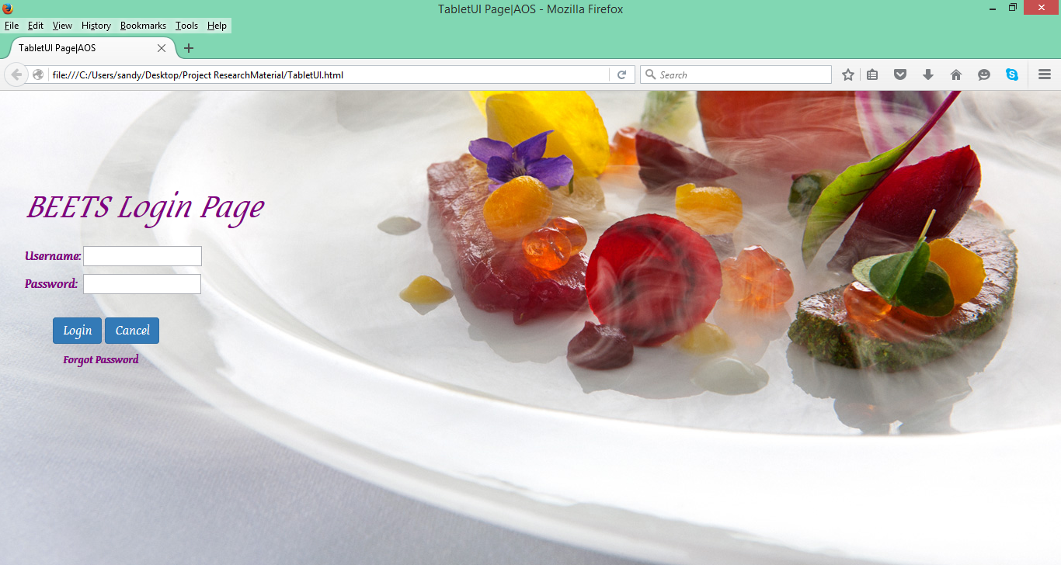

**Features Available to Waiter in TabletUI Page:**

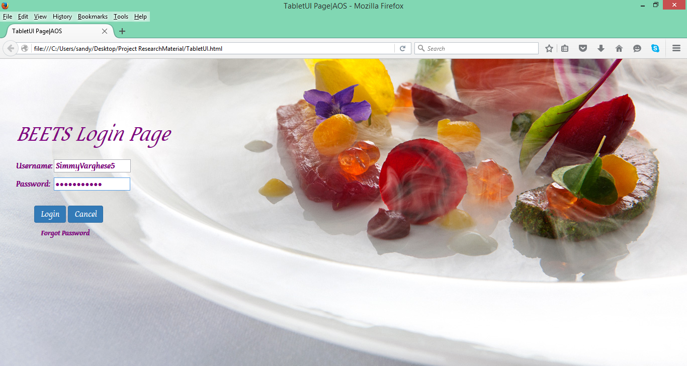

Once logged in to the system, waiter’s username will be displayed in in top-right corner of the Waiter Access Page and can access the following features: Select the table, Activate the Table, Deactivate the Table, Accept the Order, Deliver the Order, Process the payment, Notify the Chef on the order, Notify the customer on the order using the respective buttons and Logout option at the top of the page.

Below is the snap of Waiter Access Page:

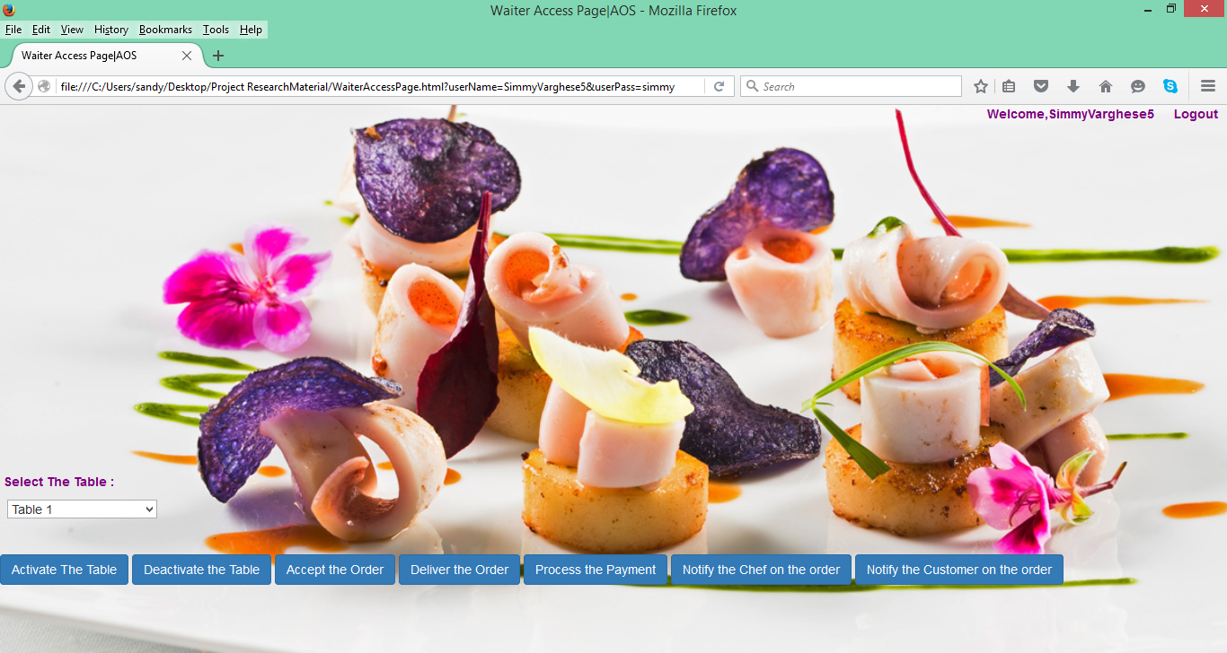

Waiter can select the table using the drop down menu and can perform the following action:

**Activate the Table:** When clicked, selected table gets activated and a pop up window appears displaying the “Table # is activated” and a timer is activated to calculate the time from activation happened. And at same time CustomerUI page appears on the activated Table.

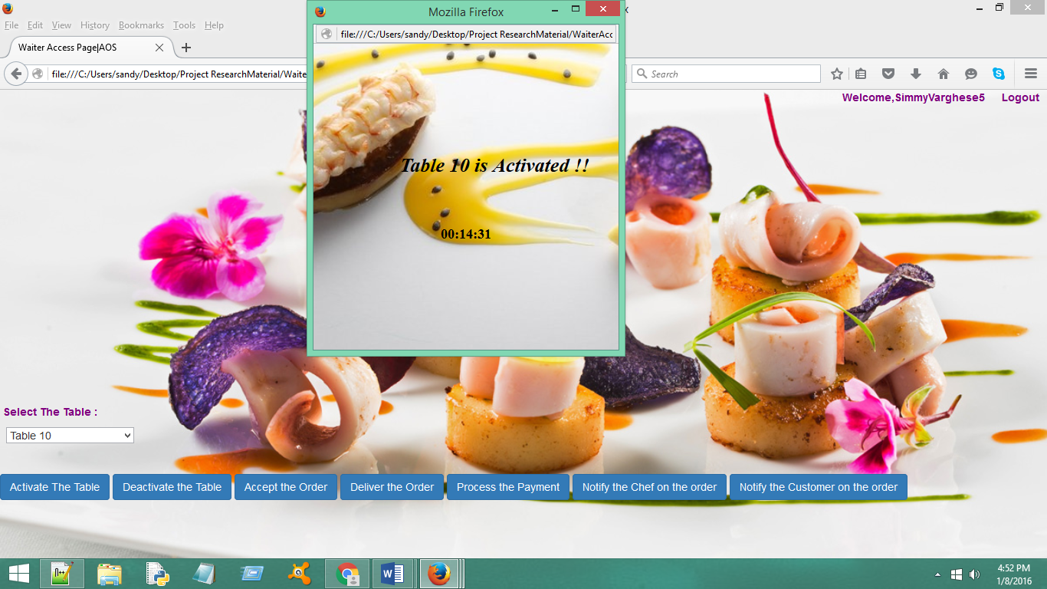

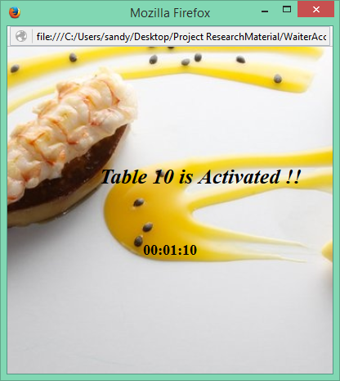

Below is the customerUI page that appears on customer’s activated table

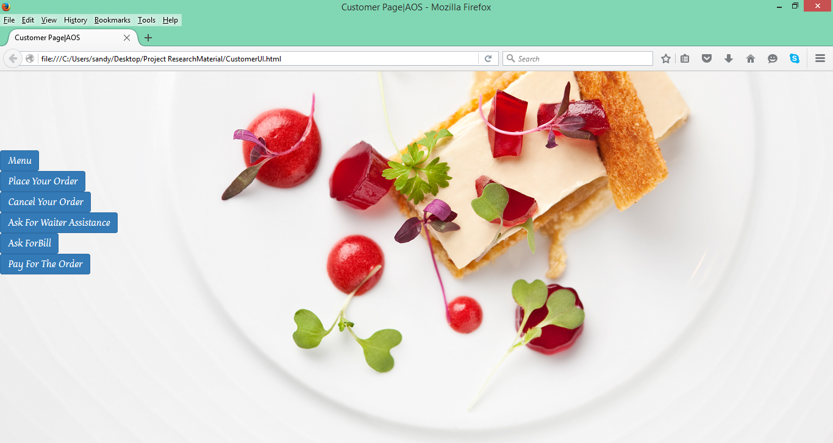

**Deactivate the Table:**Using the Deactivate the Table button, waiter can deactivate the table once the customers have payed the bill and left.A pop up window appears with the message ”Table # is deactivated”

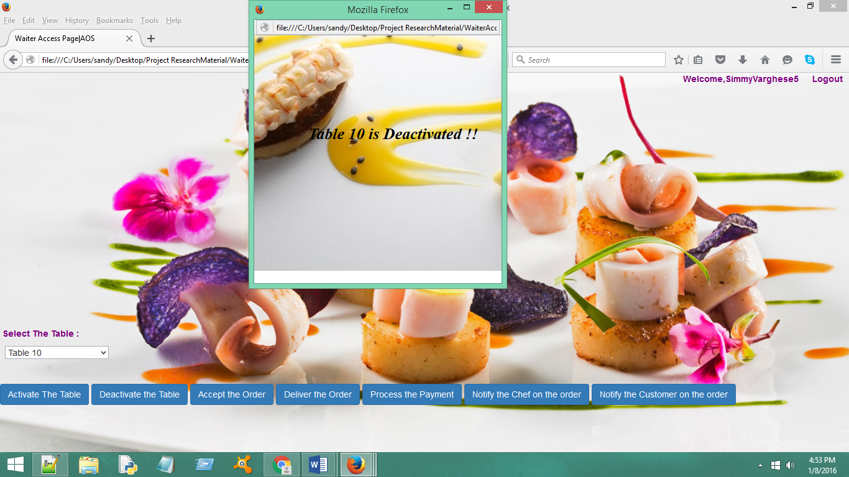

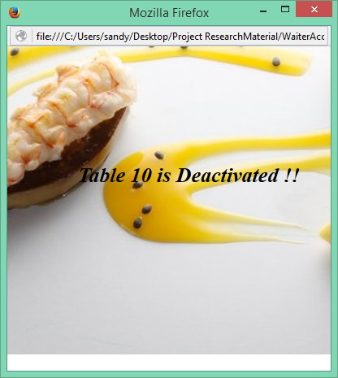

**Accept The Order:** Once the Customer places the order, waiter receives alert to the tablet and then he/she can accept the order by clicking Accept the Order button. A pop up window will appear with message “Order is accepted” alerting the customer in customer UI page that appears in customer table.

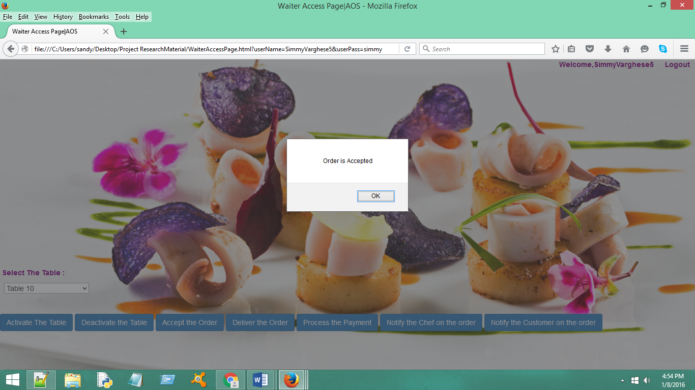

**Deliver The Item:** Once the order is ready. Waiter can deliver it and can notify the customer using Deliver the Item Button. On click, a pop up window will appear with message “Order is delivered” alerting the customer in customer UI page.

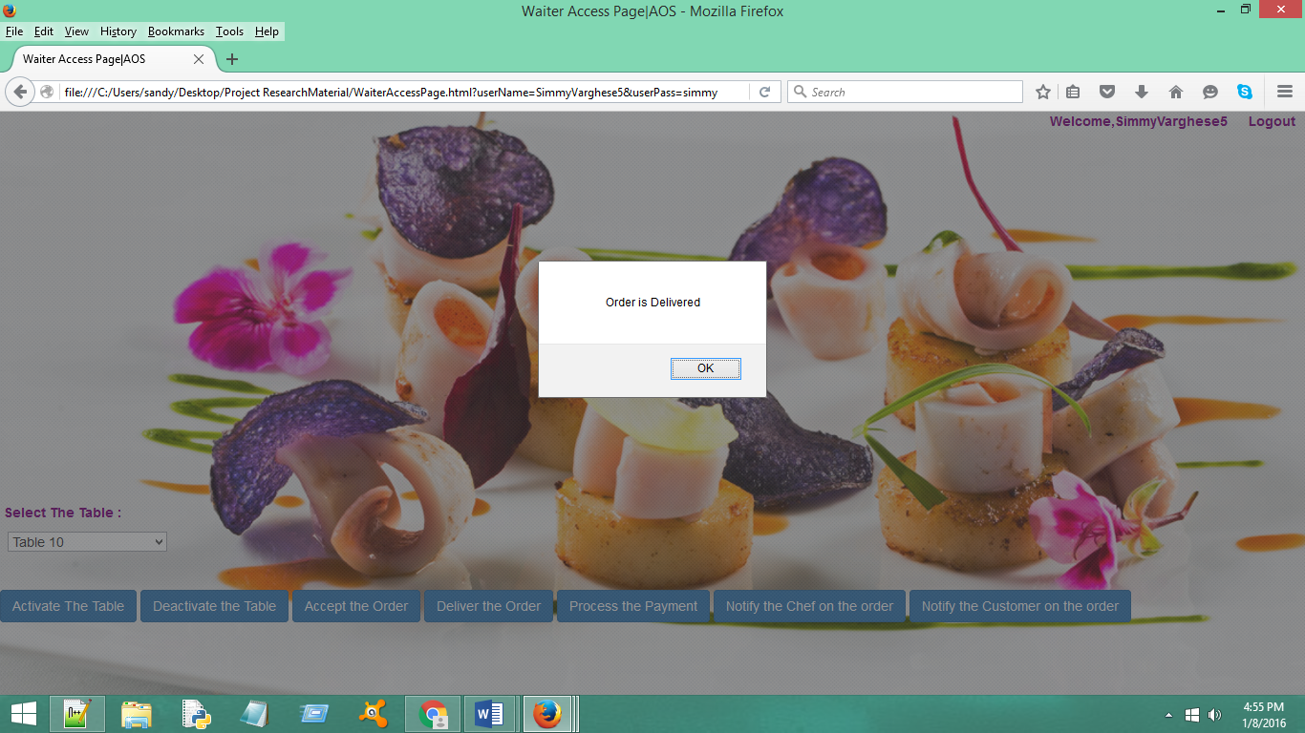

**Process the Payment:**Once the customer pays for the order using card or cash,waiter process the payment.A popup will appear indicating the status of payment process

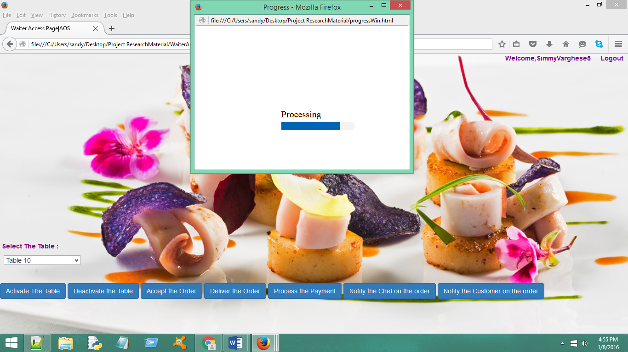

**Notify the Chef on The Order**:Once order is placed,waiter can notify the chef about the order placement using Notify the Chef on The Order Button.A popup will appear on the waiter Table page with message “Notification sent to the Chef”.Another popup will appear on the Display UI of tablet available to chef or kitchen staff indicating the order details which is not implemented in this prototype.

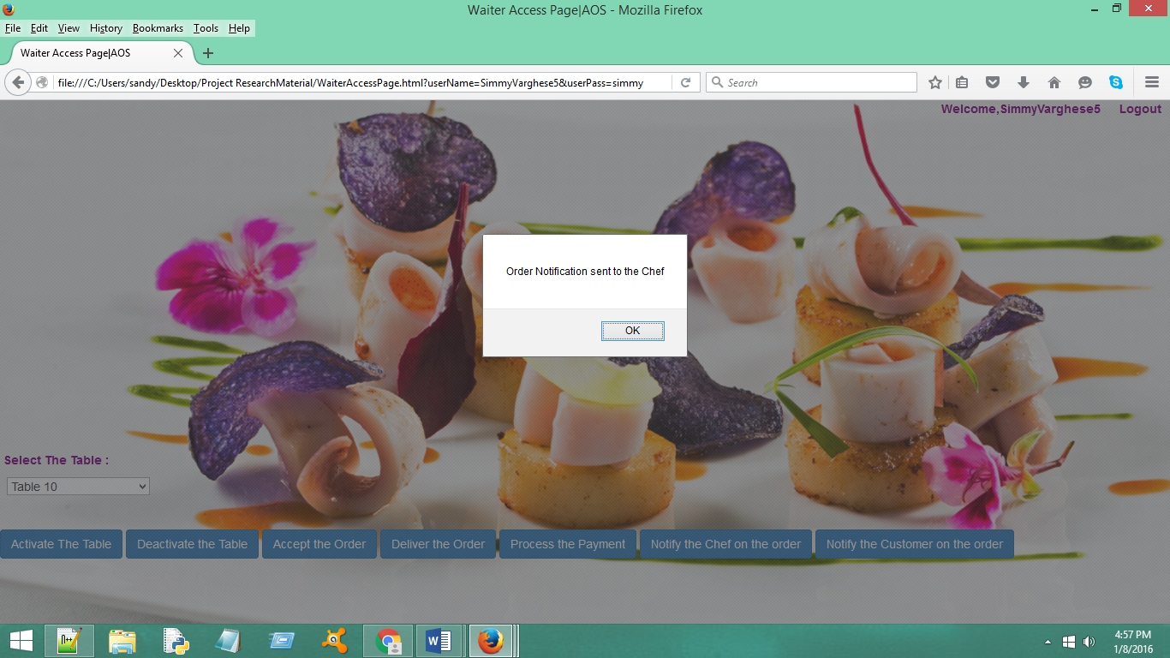

Below is the DisplayUI page that will appear on the display of the Chef.

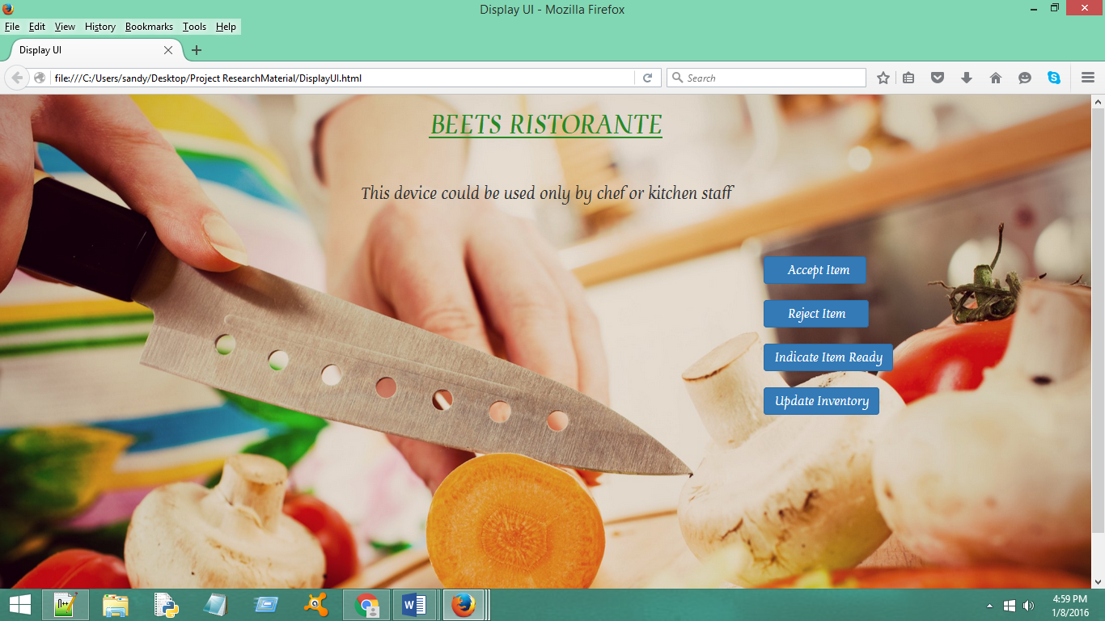

**Notify the Customer on the order:** Once order is ready,waiter can notify the customer about the status of their order using Notify the Customer on The Order Button.On click a pop up appears with the message”Notification sent to the Customer” on waiter tablet as shown below.Another pop up will appear on CustomerUI page indicating the status of the order which is not implemented in the prototype.

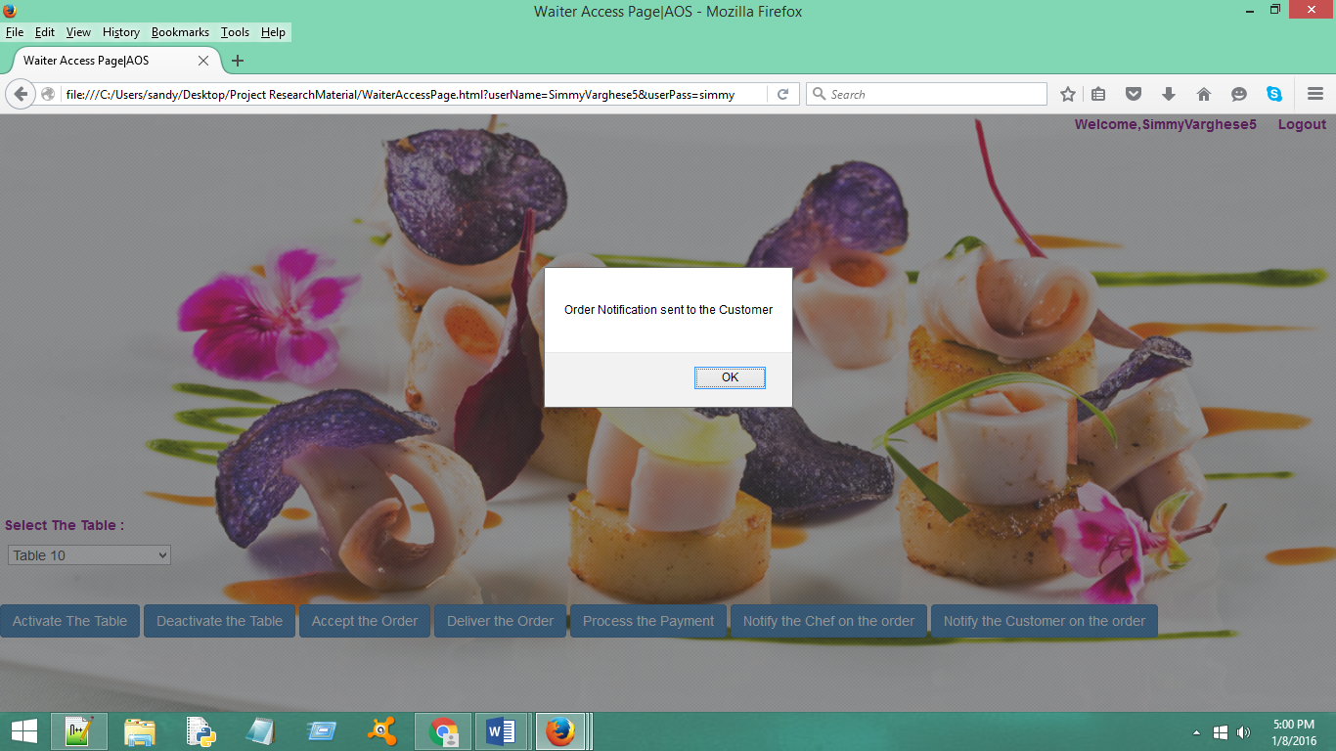

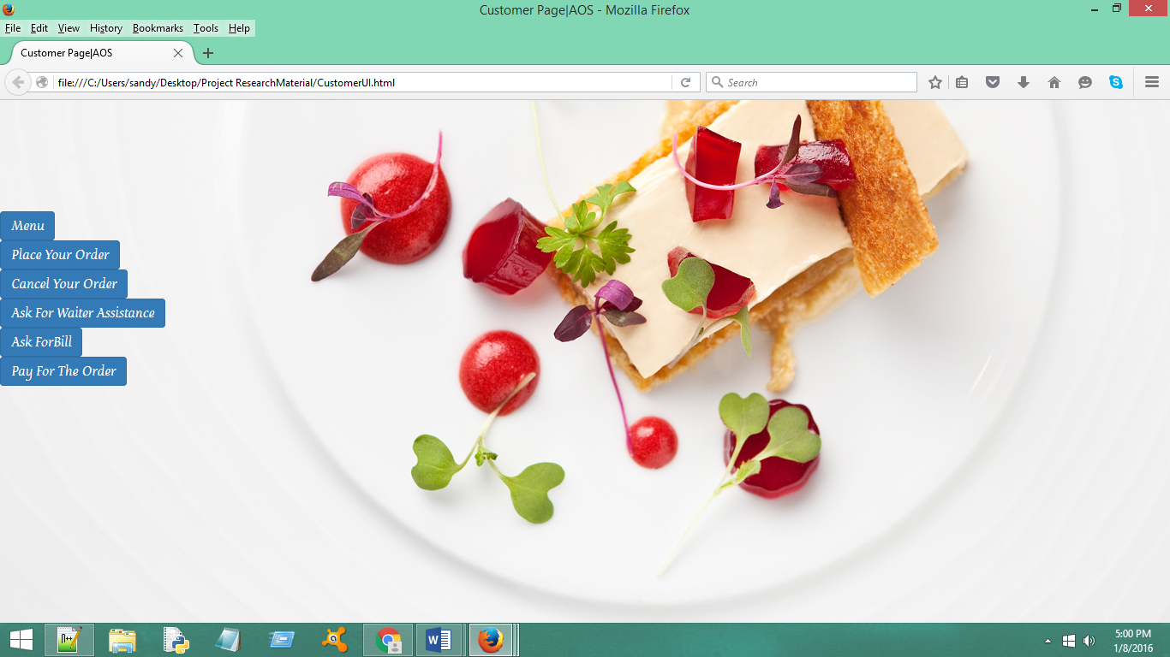

**Features Available to Customer in CustomerUI Page:**

Below is the Customer UI page which will be displayed on the customer Table.



**Menu:**

Below Page displays a static view of the menu,for customers who opt for tradional ordering

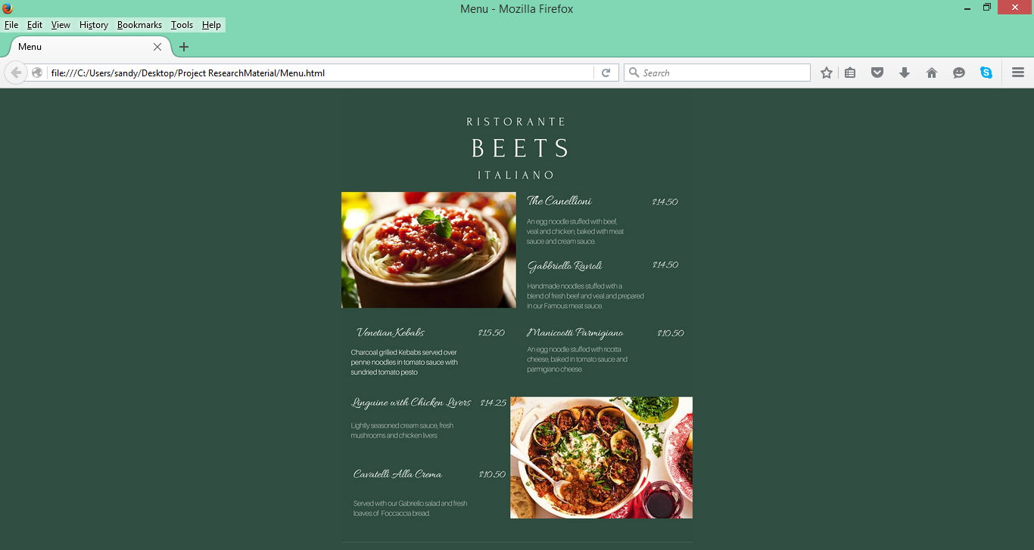

**Place The Order:**

Below is the dynamic menu page,using which customers can create and place their order.Customers can choose the quantity using the radio buttons and using Add to List /Remove From List can add or remove those items from a temperory order List

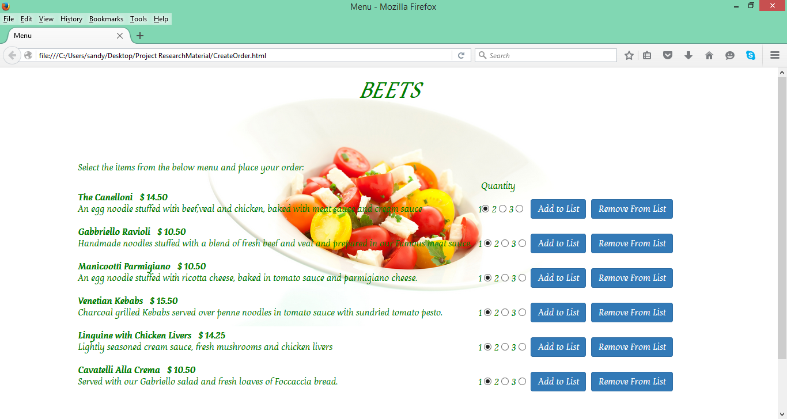

The temperory order list appears on the top-right of menu page when customer clicks on the Add to List or Remove From List Buttons.Order List will display Order Item ,Individual Price, Quantity and at the bottom Total Price of all ordered Items

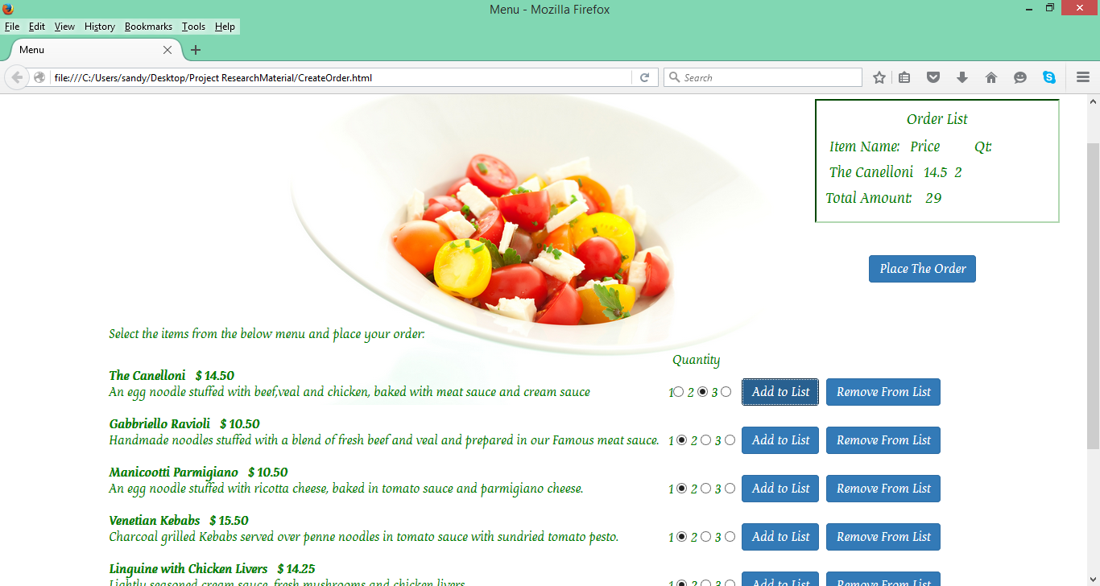

Below Page shows the ordered list with three items added.

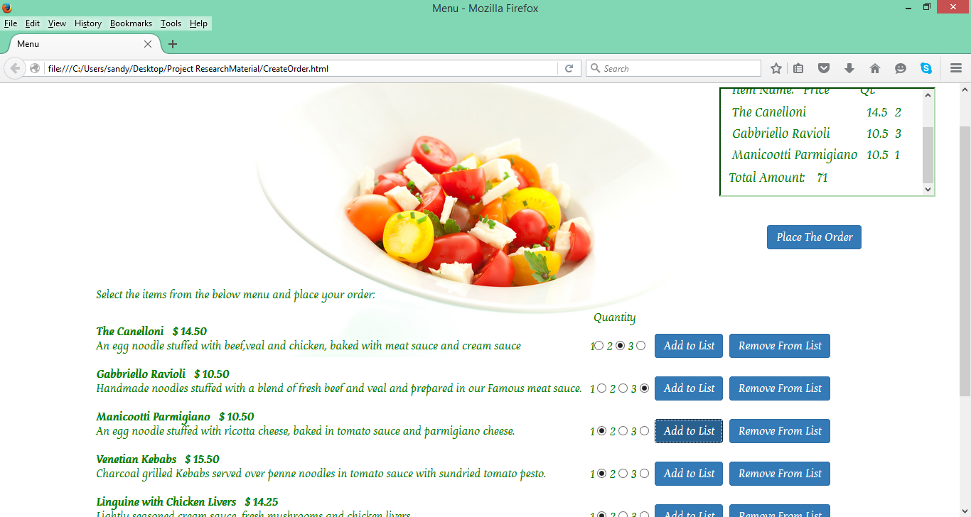

Below Page shows the last item removed from the order list and the updated total price

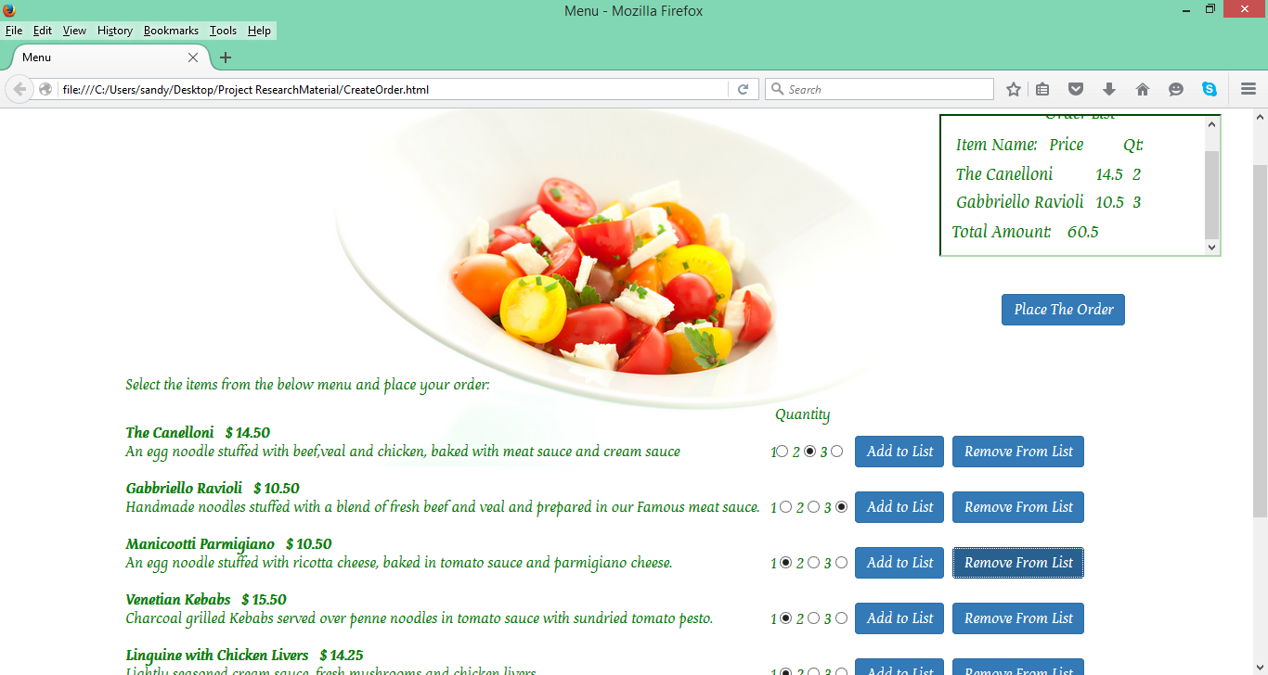

Once the customer finalize on the order by clicking Place Order button, order is placed and a pop up window appears with message “Your Order is Placed”.

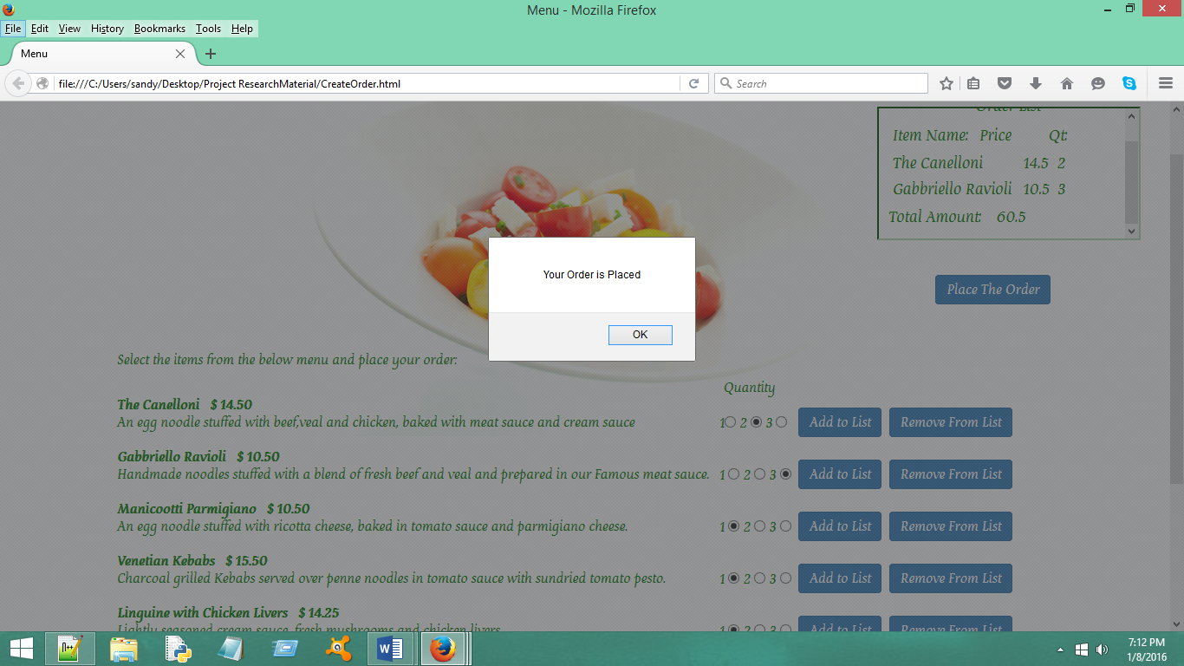

**Cancel Your Order:**

Customer can cancel the order if its not yet placed using Cancel Order button.A pop window with message “Your Order is Cancelled ” appears in the Customer UI Page.

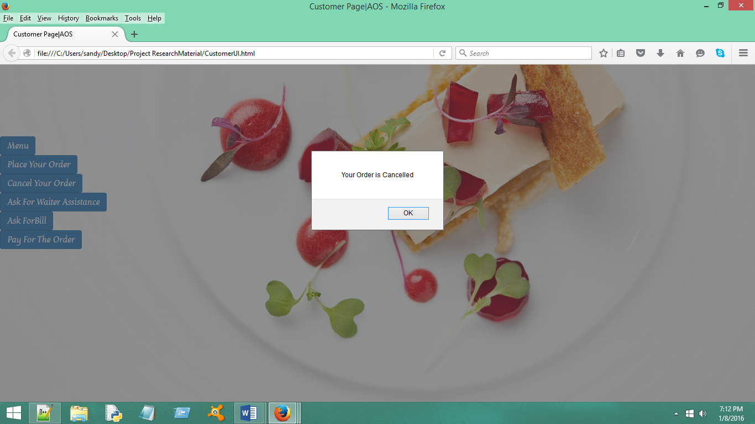

**Ask For Waiter Assistance:**

Customer can ask for waiter assistance by clicking on Ask For Waiter Assistance button.A pop up will appear with message “Your request is received by the respective waiter and will assist you soon” .And a notification will be sent to the waiter (not implemented in prototype)

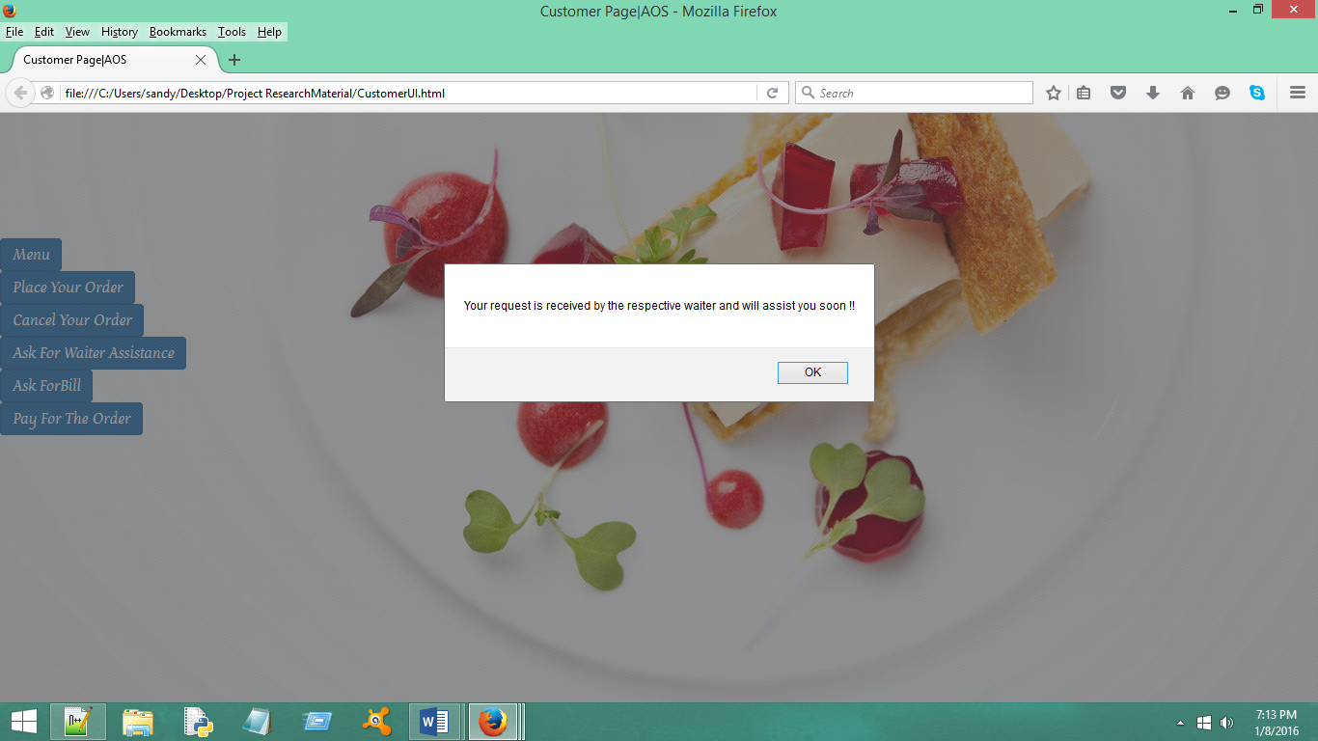

**Ask For Bill:**

Using Ask For Bill button ,Customer can ask for the bill.A pop up will appear with the message”Bill is being generated”.And also bill will be displayed to the customer(not implemented in prototype**)**

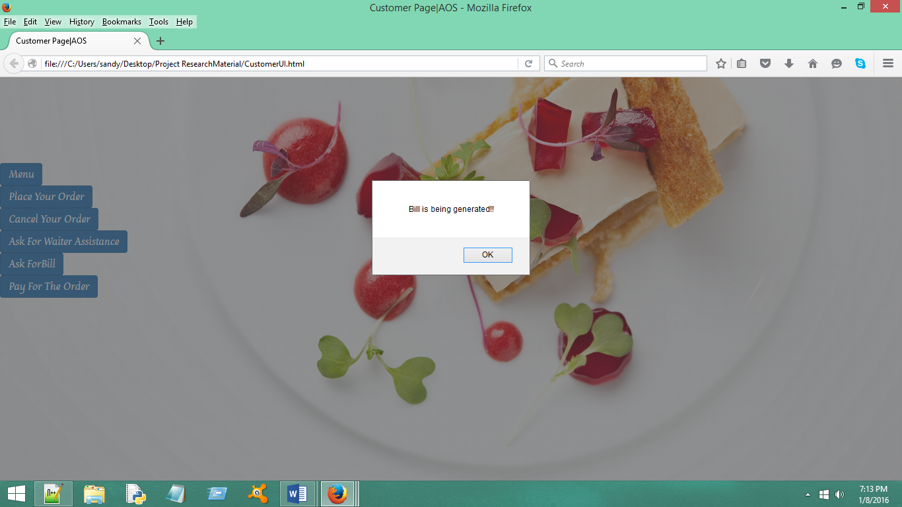

**Pay For The Order:**

Customer can pay for the order by clicking ‘Pay For The Order’ button.Customer cannot click on submit without entering the details or selecting the payment mode.

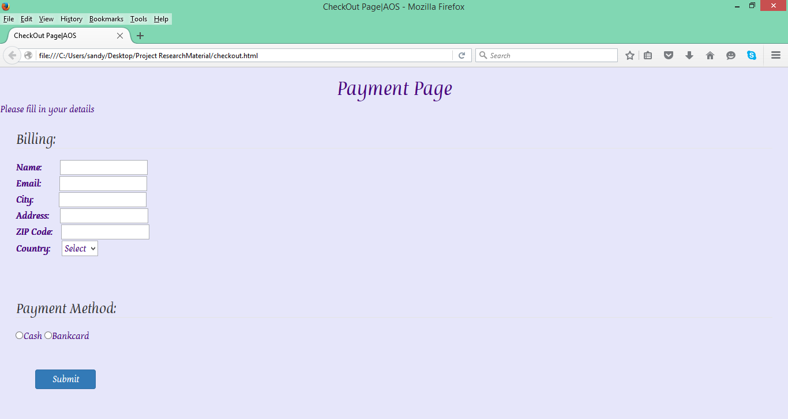

**Validations on Payment Page:**

If customer tries to click on submit without entering the detail,An error message appears on screen “Fill in the details to Proceed” as shown below:

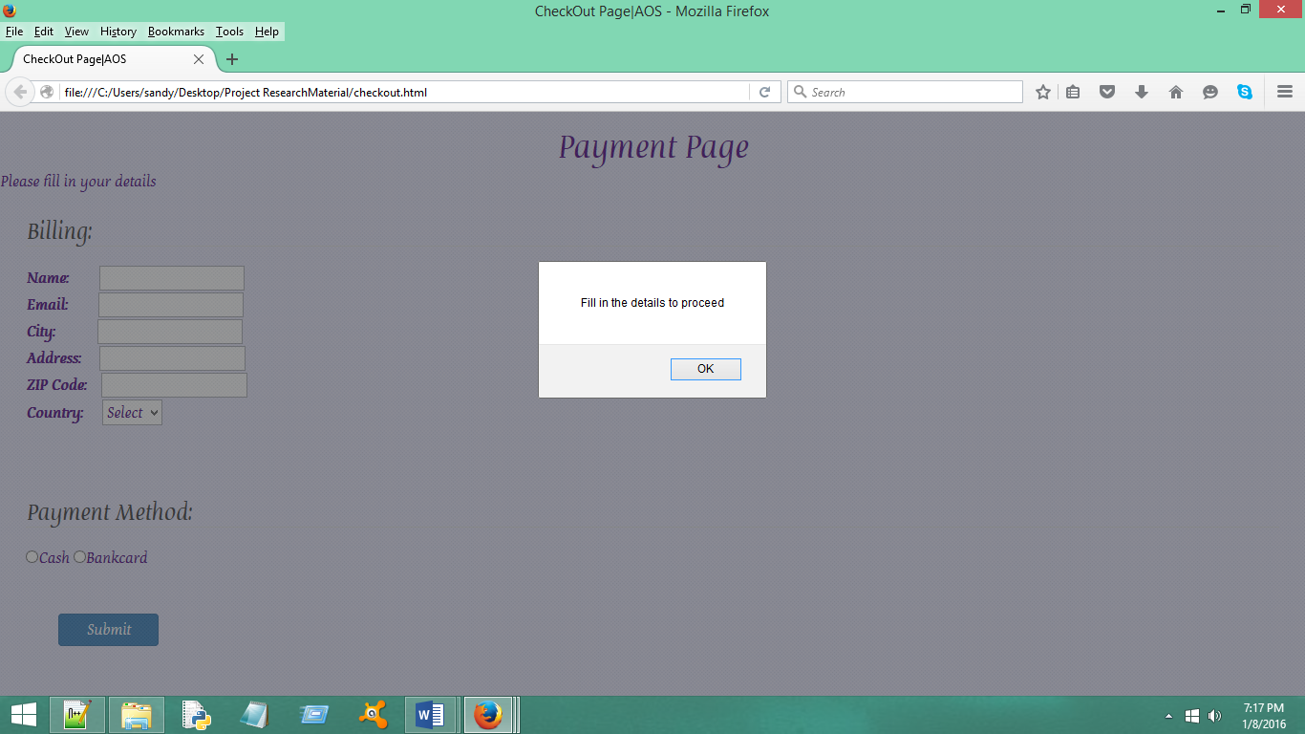

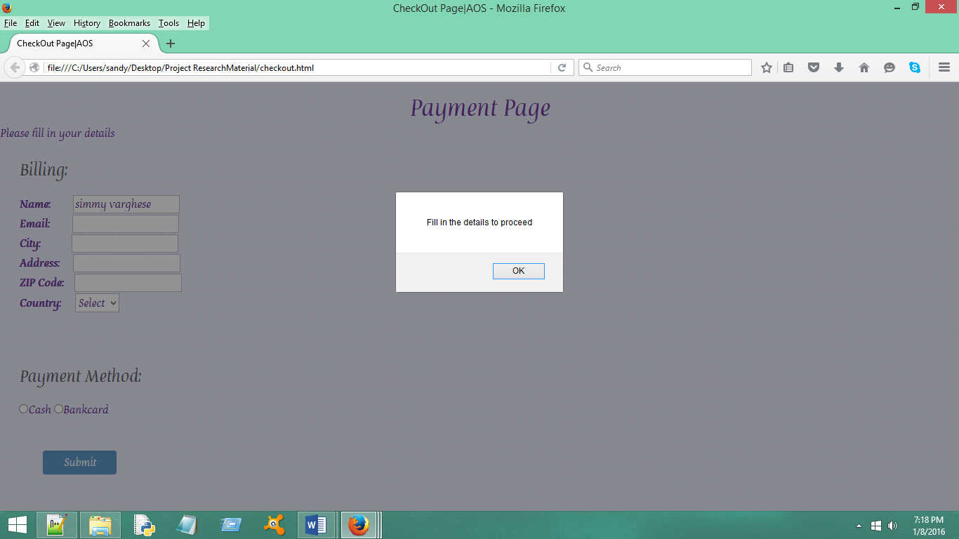

If customer tries to click on submit with all the details and without selecting the payment option .An error message appears on screen “Fill your Payment Details” as shown below:

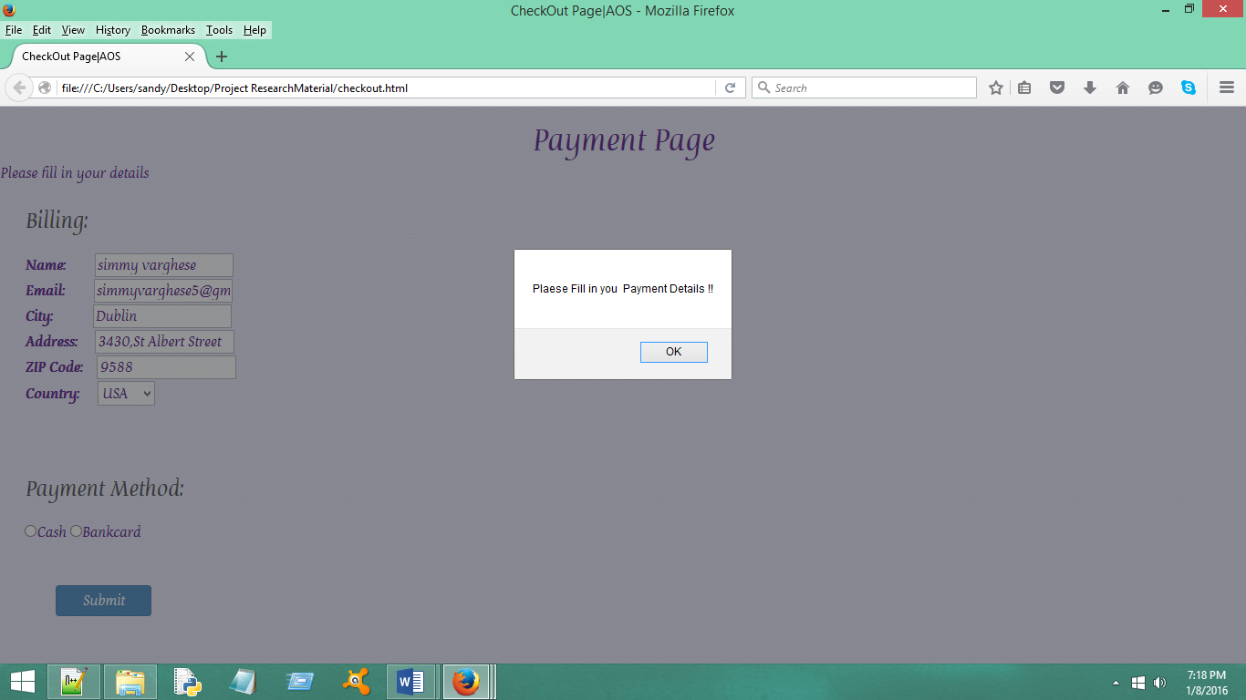

Customer can choose cash or Bankcard as a payment option.

**Using Cash:**

If customer selects cash and submit the payment.Pop up appears with the message “Thanks!!You will be assisted by the waiter for cash payment”.On click of Ok page closes.

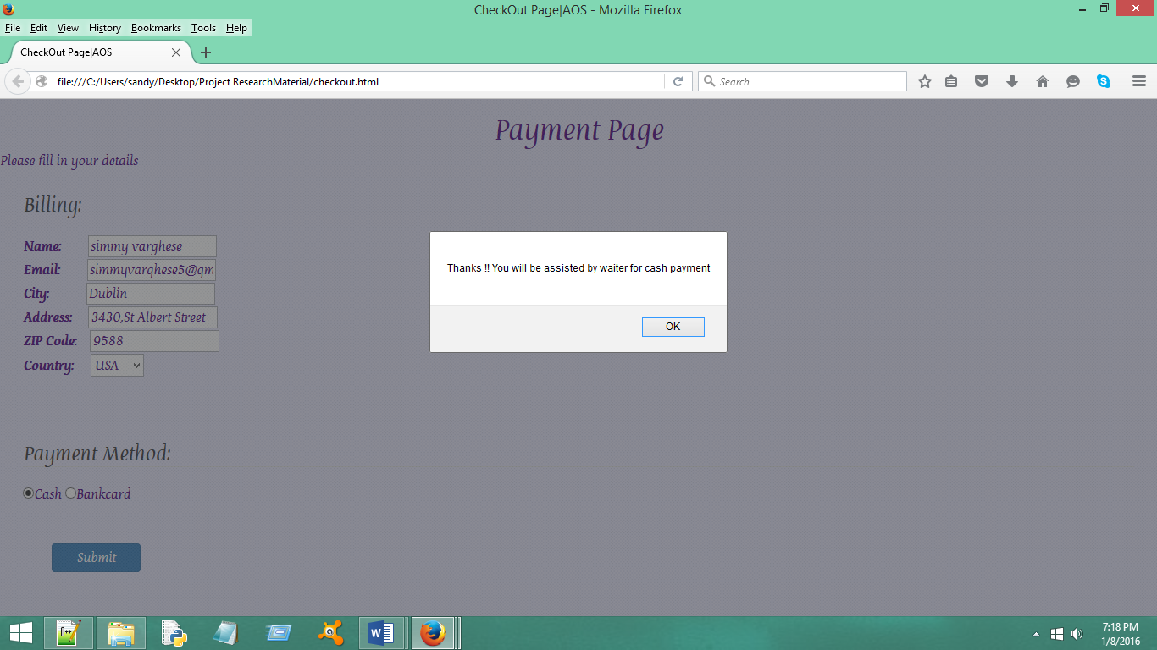

**Using Bankcard:**

If customer chooses to pay using bankcard,icons all the available cards that could be used for payment will be displayed with option for entering card number,cvv and expiry month and year.

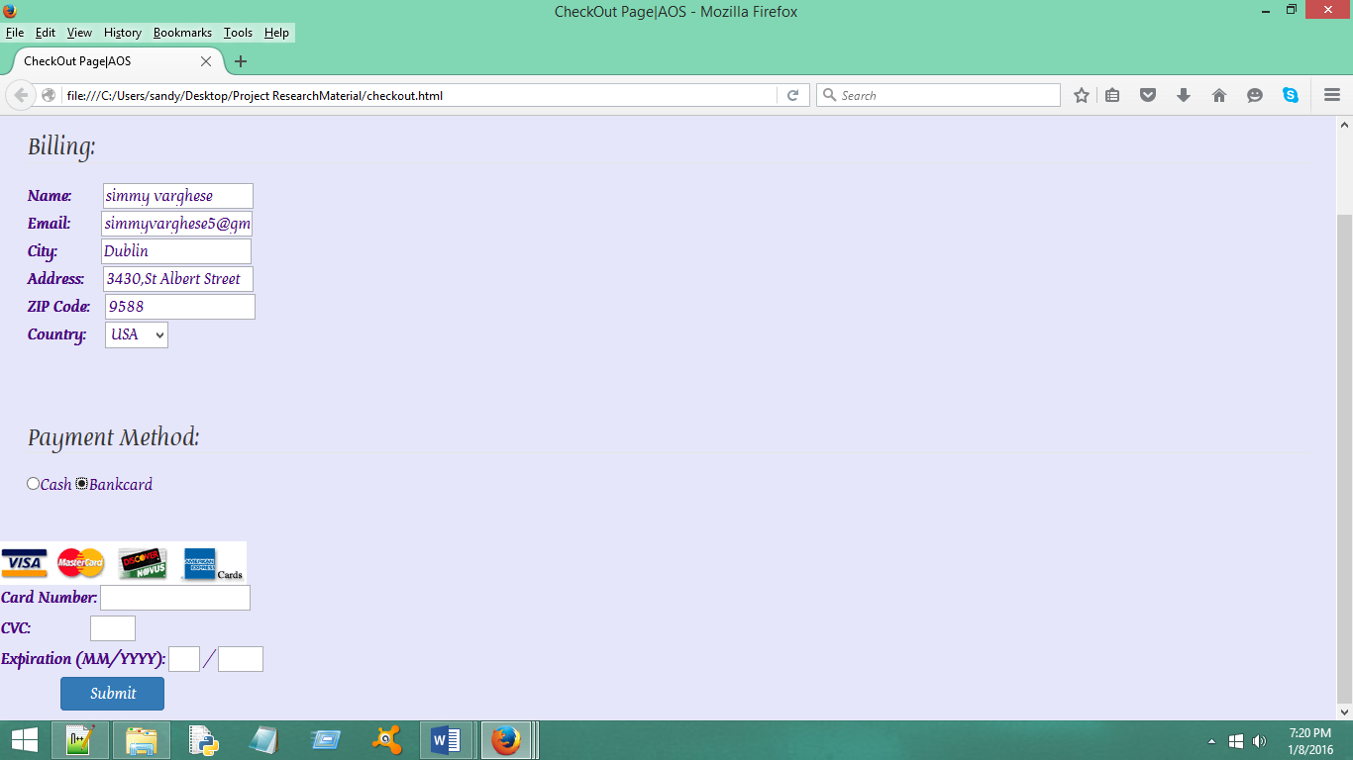

If customer donot fill the card details and submit the payment an error message occurs preventing the customer from proceeding to payment.

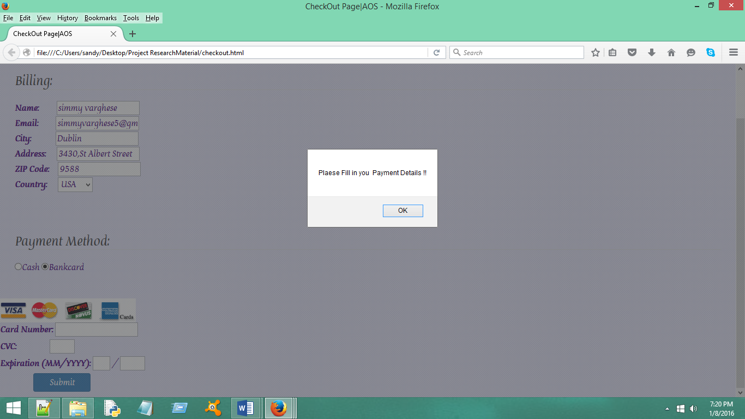

After customer fills in all the required details and payment information.On submit notification with message “Your payment is submitted ”appears.On click of OK button the payment page closes.

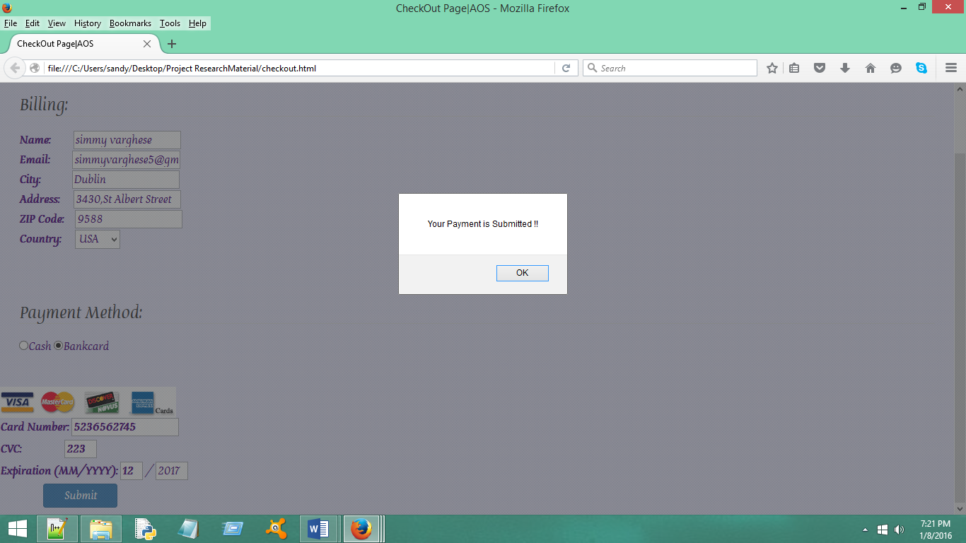

**Features Available to Chef in DisplayUI Page:**

Below is the UI page of display available to the chef

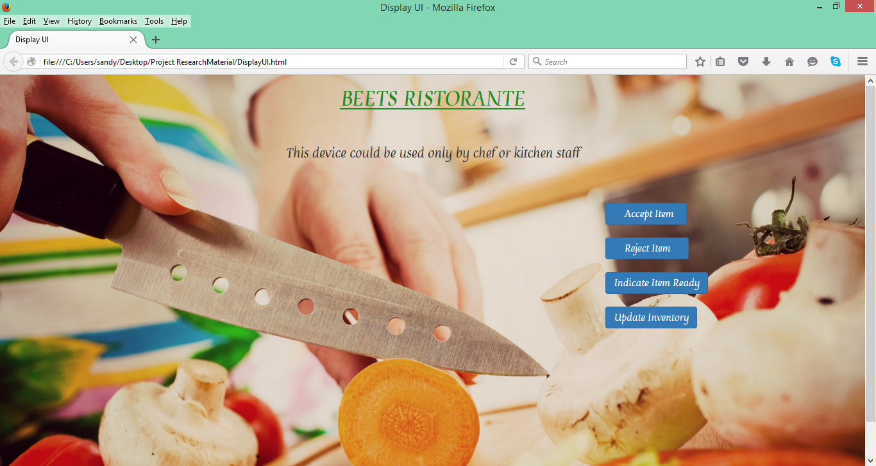

**Accept Item:**

Checf can use Accept Item button to accept the item,a pop up up window appears with message “Item Accepted” and this notification will be sent to the waiter tablet.

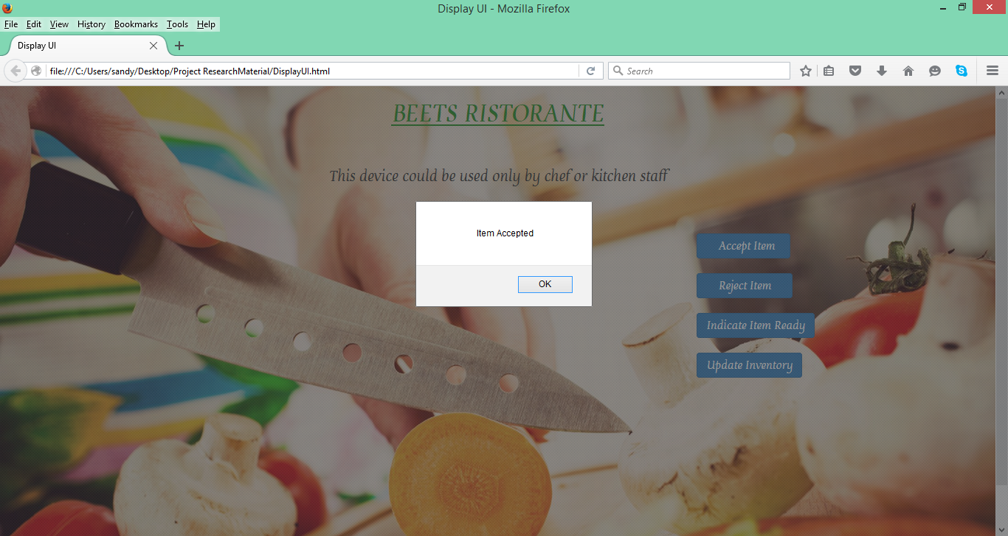

**Reject Item:**

Chef can use Reject Item button to reject the item,a pop up up window appears with message “Item Rejected” with the reason of rejection and this notification will be sent to the waiter tablet.

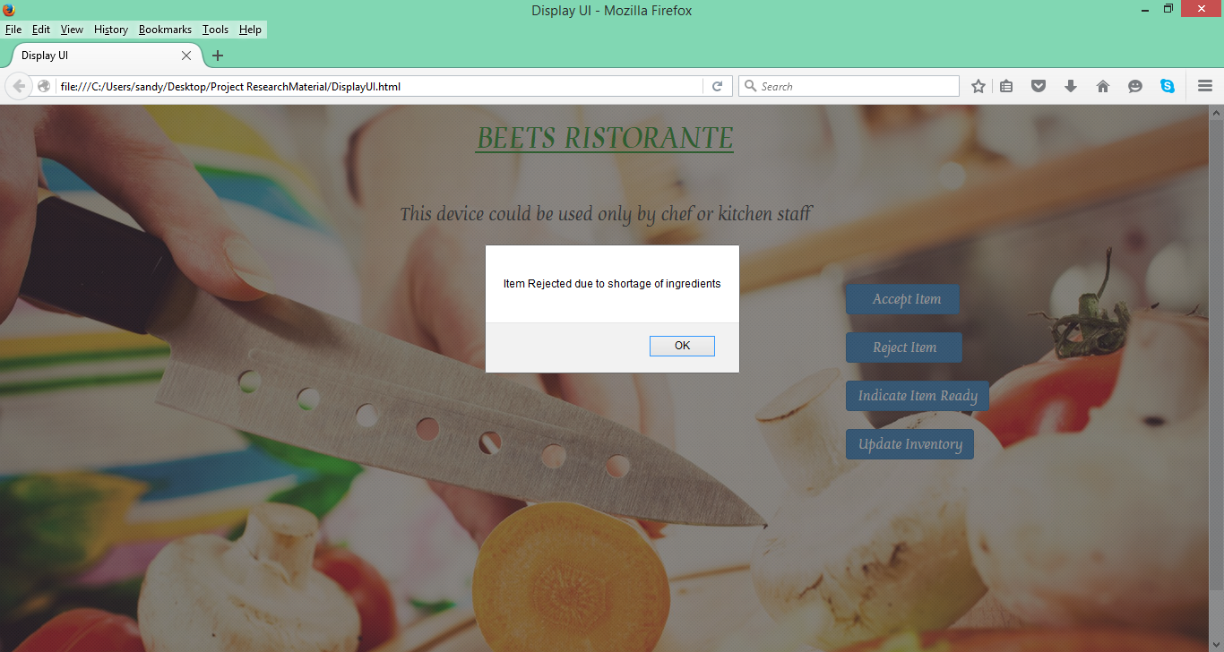

**Indicate Item ready:**

Chef can use Indicate Item Ready button to indicate when ordered meal is ready,a pop up up window appears with message “Item is ready to be served” and this notification will be sent to the waiter tablet.

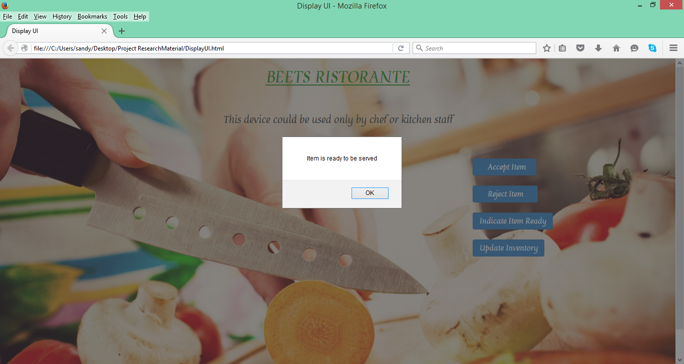

**Update inventory:**

Chef can use Update Inventory Button to update the stock of materials used for preparing the order.A pop up appears with the message “Inventory Updated”

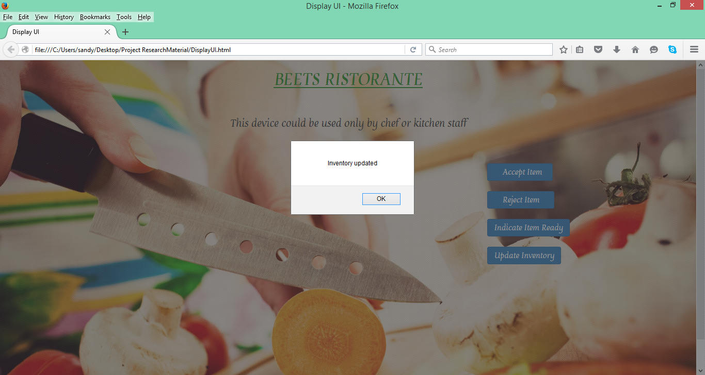

**NOTE:Code can be exceuted in all the browsers except Google Chrome for Menu.html page as it contains an iframe tag which chrome doesn’t support for local files.**